Deckard’s Dream Expander FAQ and Build Guide.
V1.7

What Does the Expander do?

The Expander provides both MIDI control changes and/or audio effects, to any sources plugged in.
Effects:
- Ring Modulator: Audio Only
- Tremolo/Chorus: Audio Only
- Delay: Audio Only
- Reverb: Audio Only
- Sustain I & II: MIDI Only

MIDI
The Expander receives across ALL (1-16) MIDI channels, and outputs only on the channel(s) it receives signals on. Example: If your controller is sending on channel 4, the Expander will receive all messages on CH4, and send only on CH4. If your controller is set to 2-16 for MPE, the Expander will send out using corresponding channels 2-16.

Note: for Sustain I&II, the expander only sends out midi pan messages on channel 1. If you are using the DDRM in poly aftertouch mode on a single midi channel other than channel 1, the expander will NOT respond to the Sustain I & II slider or switch.

Audio
The Expander takes any 2 audio sources and combines them into a single audio signal for effects processing. Balancing the audio levels must be done before input into the Expander.

How do I update the firmware?

Firmware for the MCU cannot be updated. However, the 3 main audio effects are controlled by individual SPIN FV-1 circuits, and can be augmented or modified by customizing the 1-8 programs stored on their corresponding EEPROMS. In short, you can replace the EEPROMS with your own versions.

What does the MCU do?

The MCU takes 4 inputs:
- MIDI
- High or Low signal from the Sustain I&II switch
- 0 to 3.3V from the Sustain_Level slider
- DL_Time signal from the Delay Time Slider

The MCU provides 3 outputs:
- A CLK signal for the Delay effect. This is used to clock the SPIN FV-1 circuit based on the setting of the Time slider input. This is why this IC does not use an external timing crystal like Reverb and Tremolo/Chorus do.
- The Gate signal that is generated from the MIDI input
- MIDI Control Change messages (CCs) are generated from the settings of the Sustain Level switch and Slider.

What about all the sliders, can I save patches?

Unlike the DD synth, where slider values are stored digitally for patch development and recall, and then converted back to an analog signal or voltage, the sliders on the Expander are used entirely as an analog signal or voltage. You can’t save settings for patch development or saving.

How do I hook up the Expander to my DD?

There are several ways:

- If you want to use the Sustain:
  - Controller MIDI Out -> Expander MIDI In
  - Expander MIDI Out to DD MIDI In
  - DD Audio Out to Expander Audio In
  - Expander Audio Out to Mixer/Amp

- If you just want to use Audio effects:
  - Controller MIDI Out -> DD MIDI In
  - DD Audio Out to Expander Audio In (1)
  - Another synth Out to Expander Audio In (2)
  - Expander Audio Out to Mixer/Amp
Or even:
- Controller MIDI Out -> Expander MIDI In
- Expander MIDI Out to DD MIDI In
- DD Audio Out to Mixer Line In
- Mixer Aux out to Expander Audio In (patched as an external effects send).
- Expander Audio Out to Mixer Line In (Patched as en external effect receive).

Build issues and watch points.

Testing Power:
You can effectively build and test the power circuit first, before you insert the ICs or connect the Card Board to the mother or Main Board and Hardware boards. However, you MUST have IC2 Installed to obtain a -5V power rail.

Digital and Analog grounds are separated, but joined at the point of R2 (0 Ohm resistor) on the Card board. Ensure you have a jumper wire placed into this location.

It is imperative that you double check the placement of IC4 and IC5 (3.3V voltage regulators) Vs IC3 (5V voltage regulator). These devices look almost identical. Additionally, check to ensure there are no shorts across power rails as incorrect installation could lead to a destroyed SPIN chip.

Power Switch and Connector.

There is a two pin power connector, that sits between the +Rail of the supply and the fuse. This must be bridged in order for power to flow into the system. You can use the switch on the front panel by running a wire pair to either side of the switch. We are only switching the positive rail.

Power consumption and Fuse.

The Expander draws about 650mA for operation. It is advisable to minimize potential damage by using a 750mA to 1 Amp rated fuse max. The BOM calls for a 5 Amp, but the DC/DC converter is limited to a maximum of 1.5 Amps.

Slider and Connector Soldering:
Some of the pads for the slider pins are partially cut along the board edge. This can make soldering difficult and undue stress on parts could weaken the connection. Care should be taken, use plenty of flux to ensure easy solder flow.

Like wise for the MIDI and Audio jacks. Some of the pads are hindered by the solder mask, or are too small. This can make soldering difficult, especially since the pins are a large gauge and applying enough heat to ensure a good solder joint and be challenging. Again, use plenty of flux to ensure the solder flows into the pin hole.

Slider values can be anything from 10K to 100K Linear.

Ring Modulator:

The Ring Modulator combines both audio sources into a balanced single source (SIG) which is sent to one input channel of the MC1496 Balanced Modulator circuit (IC4 on the Motherboard). An oscillator (CEM3340, AS3340) provides a sine wave (REF) which is sent to the other input channel of IC4. The ‘Speed’ slider on the front panel determines the frequency of the sine wave (signal RM_Speed). The ‘Modulation’ slider on the front panel, determines the modulation level of the audio signal by the sine wave (signal RM). It uses the VCA IC7 (V2164) for this process.

The envelope control sliders Attack, Decay, Sustain, Release provide input to the CEM3310 (AS3310) Envelope Generator circuit (IC1 on the hardware board). This EG circuit also takes a gate signal from the MCU and outputs an envelop profile signal EG_OUT, which is controlled by the ‘Depth’ Slider on the front panel. The output of this slider is effectively put into the oscillator circuit to control the amount of envelope profile, IC4 will see.

So, for the sliders:
- Modulation: controls the balance between the original audio source (Top position) and the modulated signal (Bottom position)
- Speed: Controls the modulation frequency
- Depth controls how much the EG will effect the Modulation
- Attack, Decay, Sustain and Release control the profile of the modulation

Ring Modulator Header Pins

There is a PLD-2x2 header installed right near the bottom (pins 7&8) of IC2 on the motherboard. You need to jumper pins 1 to 2, and 3 to 4 for the ring modulator to work. I would NOT recommend soldering this connection at this point. The trimming of the ring modulator must be verified by Roman.

The pin configuration (looking lengthwise over IC2, to the back edge of the card):

- 3
- 4
____
| |
| |
IC2
| |

Ring Mod Oscillator Freq header

200Hz / 2.5KHz jumpers. I don’t believe these need to be connected for operation and are possibly only for trimming the speed of the CEM3340 oscillator. TBD

Configuration of the Ring Modulator

Please note: This procedure has not been verified by Black Corporation, it is purely my suggestion based on the trimming of similar ring modular designs.

Remember, the RM controls for Attack, Decay, Sustain, Release should only be heard when the Depth slider is moved from minimum to maximum. The Depth slider controls the amount those four controls add to the modulation.
The Modulation slider: When at the top or at minimum, only the source should he heard when a key is pressed. Sliding the Modulation control down increase the amount of modulation introduced.
The Speed slider increases the frequency of the modulation: (0 to about 200Hz)

Sustain I & II

Envelope controls: Attack, Decay, Sustain and Release are much more enhanced or noticeable when this slider (right hand side of control panel) is pushed from Min (bottom) to Max (Top). This control enables MIDI messages to be sent, so the expander should be connected between the controller and the Deckard’s Dream. Calibration does not require this.

Note: for Sustain I&II, the expander only sends out midi pan messages on channel 1. If you are using the DDRM in poly aftertouch mode on a single midi channel other than channel 1, the expander will NOT respond to the Sustain I & II slider or switch.

Calibration Process:
Setup: Scope on pin 14 of IC2 (REF Signal Sine wave) and Pin 10 of IC1 (Triangle wave)
Plug headphones into the expander or use an amp
Set the volume up a bit (under headphones it can get loud so watch it)
SIG trim did not require much trimming.

REF Trim:
The idea is that a Ring Modulator or Sonic Multiplier should only respond (with the REF signal), only when an audio signal is present on the SIG channel. If there is no source there should be no sound.
Disconnect any source from the input jacks.
Set Modulation slider to max (all the way down)
Set Speed Slider to max.
Adjust REF trimmer until you can minimally hear any sound (you may not get rid of it all)
After all... multiplying anything by zero, should be zero. No SIG signal, no sound.

1) Low Frequency trim (0.2Hz trimmer)
Connect Keyboard (MIDI) to Decker’s Dream
Plug in a Deckard’s Dream into the Expander Audio input
Set Speed to Max
Set Modulation to Max
The frequency of the Sine wave and Triangle wave should be adjusted by the LF trim to about 200Hz
Moving Speed to Min results in a frequency of about 1 cycle over 4 seconds.
Note, even pressing a key on the MIDI keyboard, should not change the frequency, it should stay at about 200Hz when at Max.

2) High Frequency Trim (2.5KHz trimmer)
Keeping Speed and Modulation on Maximum
set RM Depth to Max
Set RM Sustain to Max
Press a key on the keyboard and hold it.
The frequency of the Sine wave and Triangle wave should be adjusted by the HF trim to about 2.5KHz
Now release the MIDI Key. The Frequency should drop back to 200Hz
You need to keep adjusting both trimmers until you get a good approximation of these two values.
Mine was finally set to LF = 210Hz, HF = 2.27KHz
Note Sliding the RM Sustain or Depth back to min puts the frequency back to about 200Hz
Keeping RM Sustain or Depth on Max and sliding the Speed back to min, results is a Frequency of about 2 cycles per second.

The minute a key is released, all current effects from the ring modulator should stop, or (depending on how close to the maximums are), the envelopes, etc should decay back to silence fairly quick. This gets a little more pronounced when the added MIDI effect of the Sustain I or II is added to this mix. Without any Sustain I or II, there is still some amount of signal seep when all the RM controls are maxed, and I have not yet figured out how to stop it

BUILD Issues, Mods, etc

MIDI out, and MIDI Thru BOM Changes

There is not enough current (under 5mA) for some MIDI receiving devices to work properly when connected to the Expander MIDI out. To increase the output current reduce R160 on the Card board, from a 220 OHM to a 51 Ohm resistor.

Likewise for the Expander MIDI-Thru circuit, R167 must be reduced from 200 Ohms to 47 ohms, and R166 must be reduced from 220 Ohms to 51 ohms

MIDI Noise Issue.

There is some digital noise being created by the Schmitt Trigger IC35 and its close proximity to both the external analog signal supply and to the output op amp IC33 on the Card board. This is purely a use case matter and your tolerance level or acceptability level of what ‘Noise’ is. So don’t feel that you have to do this, everything will work and generally analog after effects equipment is typically filled with noise when gain or signal levels are near maximums.

The best way to hear the noise is to unplug all inputs, leave the output jack into the mixer/amp and crank the gain up. Then play a midi controller or send a midi signal. Bear in mind, this unit has a lot of inherent noise in the effects when everything is near maximums. Turning on and off the unit creates a fairly nasty “Thump”, so standard mixer/Amp practice applies.

MIDI Noise remediation (Card Board):

- Reflow all solder joints, ensure lead cutoffs are short in the area. Test for noise levels, if they are still not tolerable proceed to step 2

- Connect pin 11 to pin 12 on IC35 (SN74hc14). This typically should eliminate 50% of the noise. Test for noise levels, if they are still not tolerable proceed to steps 3 and 4

- Relocate resistors R153 & R157 and connect shielded cable(s) as shown below.

- Cut the audio trace that runs from R157 to pin 2 of IC33 as close to IC33-pin2 as possible
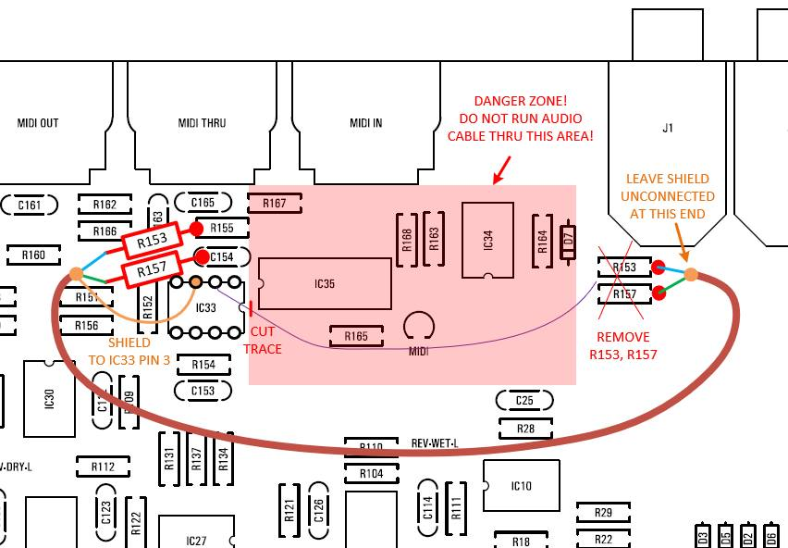
Image courtesy of Ando Pilve

Installation of the Expander circuits into the DIY Case.

The Card PCB sites very close to the bottom of the pan. It is advisable to ensure all pins are trimmed and a thin plastic, or insulate material be placed between the bottom of the PCB and the pan to avoid any potential short.

